**EXPERIMENT – 1**

**AIM: -** Study of various Network commands used in Linux and Windows

**BASIC NETWORKING COMMANDS: -**

**Windows:**

**arp –a:** ARP is short form of address resolution protocol, It will show the IP address of your

computer along with the IP address and MAC address of your router.

**hostname:** This is the simplest of all TCP/IP commands. It simply displays the name of your

computer.

**ipconfig /all:** This command displays detailed configuration information about your TCP/IP

connection including Router, Gateway, DNS, DHCP, and type of Ethernet adapter in your

system

**nbtstat –a:** This command helps solve problems with NetBIOS name resolution. (Nbt stands

for NetBIOS over TCP/IP)

**netstat:** (network statistics) netstat displays a variety of statistics about a computers active

TCP/IP connections. It is a command line tool for monitoring network connections both

incoming and outgoing as well as viewing routing tables, interface statistics etc.

e.g.:- netstat -r

**nslookup:** (name server lookup) is a tool used to perform DNS lookups in Linux. It is used to

display DNS details, such as the IP address of a particular computer, the MX records for a

domain or the NS servers of a domain. nslookup can operate in two modes: interactive and

non-interactive.

e.g.:- nslookup www.google.com

**pathping:** Pathping is unique to Window’s, and is basically a combination of the Ping and

Tracert commands. Pathping traces the route to the destination address then launches a 25

second test of each router along the way, gathering statistics on the rate of data loss along eachhop.

**ping:** (Packet INternet Groper) command is the best way to test connectivity between two

nodes. Ping use ICMP (Internet Control Message Protocol) to communicate to other devices.

1. #ping hostname( ping localhost)

2. #ping ip address (ping 4.2.2.2)

3. #ping fully qualified domain name(ping www.facebook.com

Route: route command is used to show/manipulate the IP routing table. It is primarily used

to setup static routes to specific host or networks via an interface.

**OUTPUT: -**

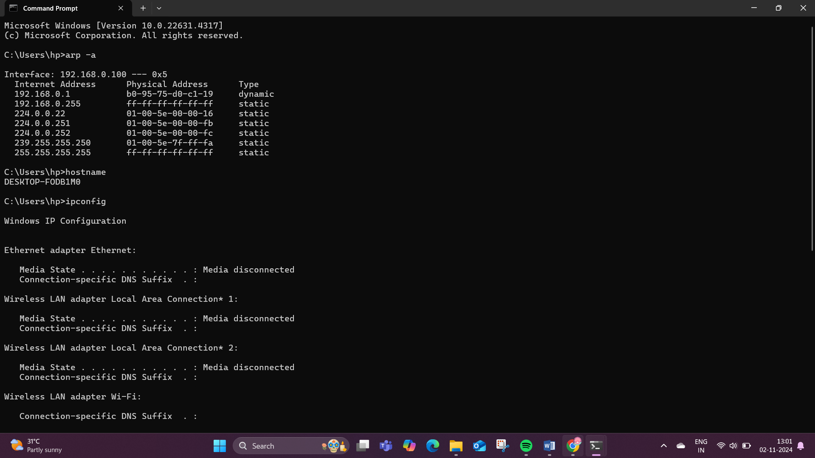

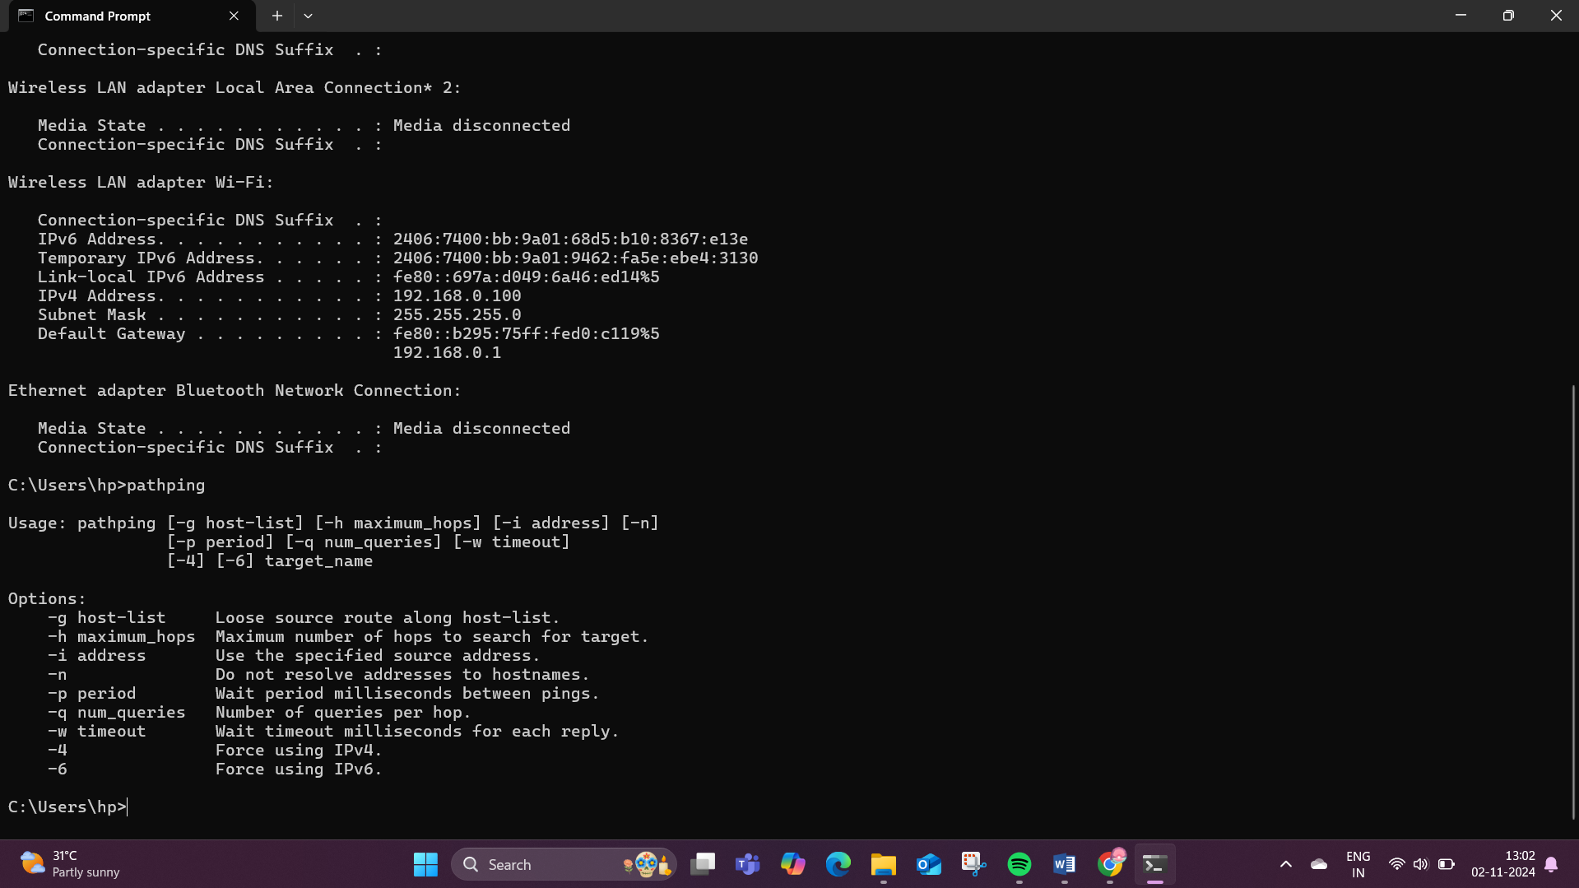

**Linux:**

**ip:** The ip command is one of the basic commands every administrator will need in daily

work, from setting up new systems and assigning IPs to troubleshooting existing systems.

The ip command can show address information, manipulate routing, plus display network

various devices, interfaces, and tunnels.

**ifconfig:** The ifconfig command was/is a staple in many sysadmin's tool belt for configuring and troubleshooting networks. It has since been replaced by the ip command discussed above.

**mtr:** MTR (Matt's traceroute) is a program with a command-line interface that serves as a

network diagnostic and troubleshooting tool. This command combines the functionality

of the ping and traceroute commands. Just like a traceroute, the mtr command will show

the route from a computer to a specified host. mtr provides a lot of statistics about each

hop, such as response time and percentage. With the mtr command, you will get more

information about the route and be able to see problematic devices along the way. If you

see a sudden increase in response time or packet loss, then obviously, there is a bad link

somewhere.

The syntax of the command is as follows:

mtr <options> hostname/IP

**tcpdump:** The tcpdump command is designed for capturing and displaying packets.

**ping:** verifies IP-level connectivity to another TCP/IP computer by sending

Internet Control Message Protocol (ICMP) Echo Request messages. The receipt of

corresponding Echo Reply messages is displayed, along with round-trip times. Ping is the

primary TCP/IP command used to troubleshoot connectivity, reachability, and name

resolution.

**OUTPUT: -**

**RESULT: -**

The commands for Linux and Windows has been executed successfully and the output is verified.